Architecture

1. Core system components
   * MySql Database
   * Azure
   * Azure Functions App
   * Rest
   * Twitter Api
   * Azure Logic Apps
   * Ocelot
   * RabbitMQ
2. 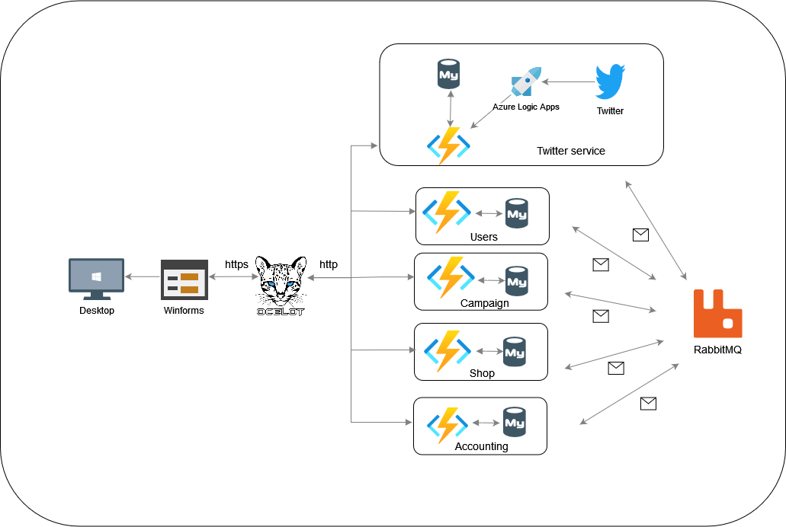Architecture Diagra
3. 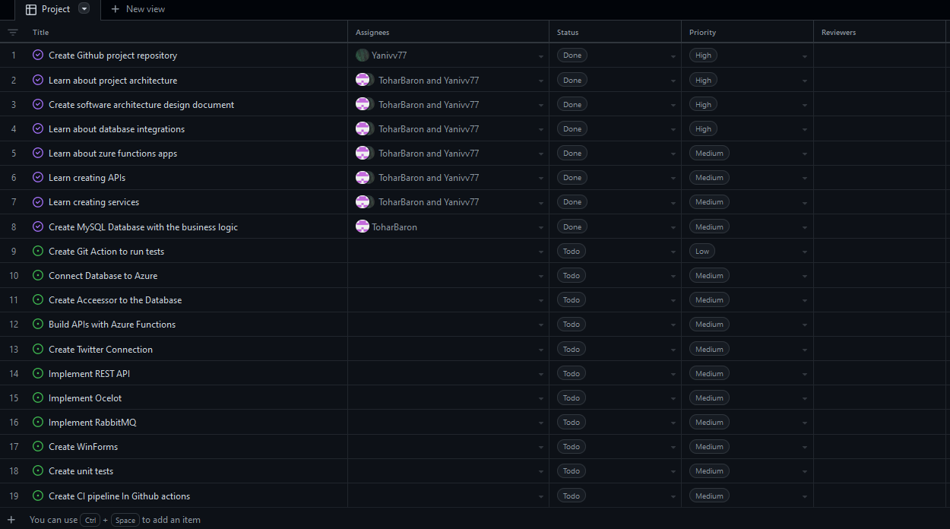High Level Tasks